

MESTNA OBČINA KOPER

COMUNE CITTA` DI CAPODISTRIA

COMMUNITY OF KOPER

world-wide-web<https://sites.google.com/site/judo15majmarezige/>; <http://judoklubobala.wixsite.com/judo-klub-marezige>;

http://194.249.196.220/Splet2010/projekt2b10/icon_facebook.jpeg.png

<https://www.facebook.com/Judo-Klub-Marezige-1592439607697243/?ref=bookmarks>;

14th INTERNATIONAL TOURNAMENT

**JUDO CUP KOPER 2016**

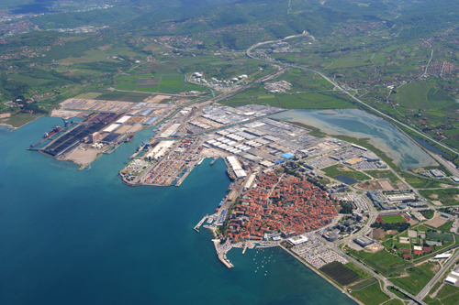

*Dear judo friends,*

Judo club“15. maj Marezige” under the aegis of Community of Koper is happy to invite you to the 14th International judo tournament “Judo Cup Koper 2016”.

LOCATION:

Sport hall Arena Bonifika

Zora Perello Godina Street, 3

6000 Koper, SLOVENIA

DATE:

Sunday 16th October 2016

CATEGORIES:

* cadets (U-18) born in 1999, 2000 (and 2001);
* minor cadets (U-16) born in 2001 and 2002;
* boys and girls (U-14) born in 2003 and 2004;
* minor boys and girls (U-12) born in 2005 and 2006;
* children (U-10) born in 2007 and 2008 (2009).

WEIGHT DIVISIONS FOR ALL CATEGORIES:

*»U-18« born in 1997, 1998 (and 1999):*

* Men: - 46kg ,- 50 kg, - 55 kg, -60 kg, - 66 kg, - 73 kg,- 81 kg , -90 kg and + 90 kg;
* Women: - 40kg,-44kg, - 48 kg, - 52kg, - 57 kg, - 63kg, - 70kg and + 70 kg;

*»U-16« born in 1999 and 2000:*

* Boys:- 42kg,- 46kg, - 50kg, - 55 kg, - 60kg, - 66kg, -73 kg, - 81 kg and + 81 kg;
* Girls: - 36 kg, - 40 kg, - 44 kg, - 48 kg, - 52 kg, - 57 kg, - 63 kg, -70 kg and + 70 kg;

*»U-14« born in 2001 and 2002:*

* Boys :- 30kg, -34kg, -38kg, -42kg, 46kg, -50kg, - 55kg - 60 kg and + 60 kg;
* Girls: -28 kg, -32kg, -36kg, -40kg, -44kg,-48kg, -52 kg, -57 and + 57 kg;

*»U-12« born in 2003, 2004:*• Boys : - 27 kg, - 29 kg, 32kg, -35kg, -38kg, -42kg, -46kg, -50kg, - 55kg and + 55 kg;  
• Girls: 25 kg, -27 kg, -30kg, -33 kg, -36kg, -40kg, -44kg,-48kg, -52 kg, and + 52 kg;

*»U-10«* born in *2005, 2006:*

* *The competition of children will be held in accordance to adapted rules. Boys and girls will be distributed into 8 competitors (weight level) in each group.*

REGISTRATION AND WEIGH-IN

- *»U-12«*

*- »U-10«*

Sunday 16th October 2016 from 8:00hrs – 9:15 hrs

The competition will start at 10:00hrs a.m.

REGISTRATION AND WEIGH-IN:

*- »U-14«*

*- »U-16«*

*- »U-18«*

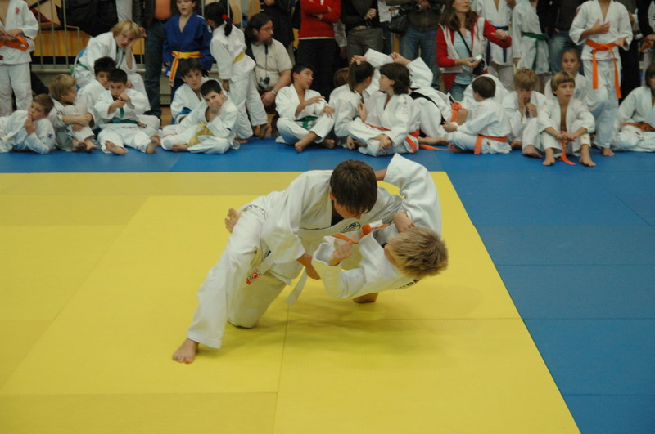Sunday 11th October 2016 from 11:00hrs - 12:00 hrs a.m.

The competition will start at 12:30 hrs p.m.

POINTS:

* 1st place: 10 points
* 2nd place: 7 points
* 3rd place: 3 points

PRIZES:

* medal for the first four athletes of each category
* cup for the first six teams (U-12, U-14, U-16 and U-18)

COMPETITION FEE:

The tournament fee is 12 *€* per competitor and it is paid on the day of the tournament at the registration. Unregistered teams pay 15 *€* per competitor. Registration deadline is Wednesday 12th October 2016. For registration please use the entry form below.

*18,00 €* for double start with entry form before 12th October 2016

*22,00 €* for double start for unregistered teams (with entry form).

PRECEDING ENTRY FOR THE TOURNAMENT:

Teams can register sooner and a registration list will be at their disposal on the day of the tournament. The list is open to eventual change.

The organizer holds the right to change the rules in case of objective reasons. For more information call the mobile phone: 00386 31 625 170, contact person Iztok Babic.

***Please send the preceding entry to:*** E- mail: [iztok.babič@siol.net](mailto:iztok.babič@siol.net);

WHERE ARE WE SITUATED?

Koper is a city on the Slovenian coast. It borders with Italy and Croatia.

HOW CAN YOU REACH KOPER?

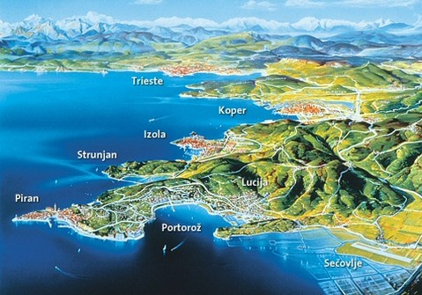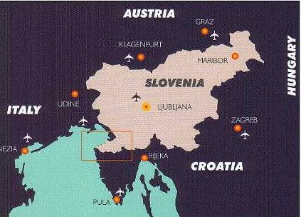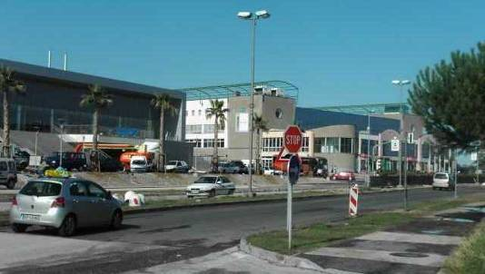You can reach Koper via major highways from Italy, Austria, Hungary (via Koper), and Croatia (via Rijeka or Pula). When you reach Koper travelling on the A1 highway turn right at the second exit towards town center, then take the first exit from the round crossroads and the sport center Bonifika will be on your right. If you travel by plane the nearest airports are the International [Airport of Ljubljana](http://www.lju-airport.si/eng/default.asp), Slovenia (Jože Pučnik - 23 km northwest of the capital Ljubljana and 150 km away from Koper) and the International [Airport of Trieste](http://www.aeroporto.fvg.it/UK/html/index.html), Italy (Ronchi - 65 km away from Koper).

*SLOVENIA KOPER-CAPODISTRIA SPORT HALL BONIFIKA*

SCHEME

1000: U-12

1330: U-16

1400: U-18

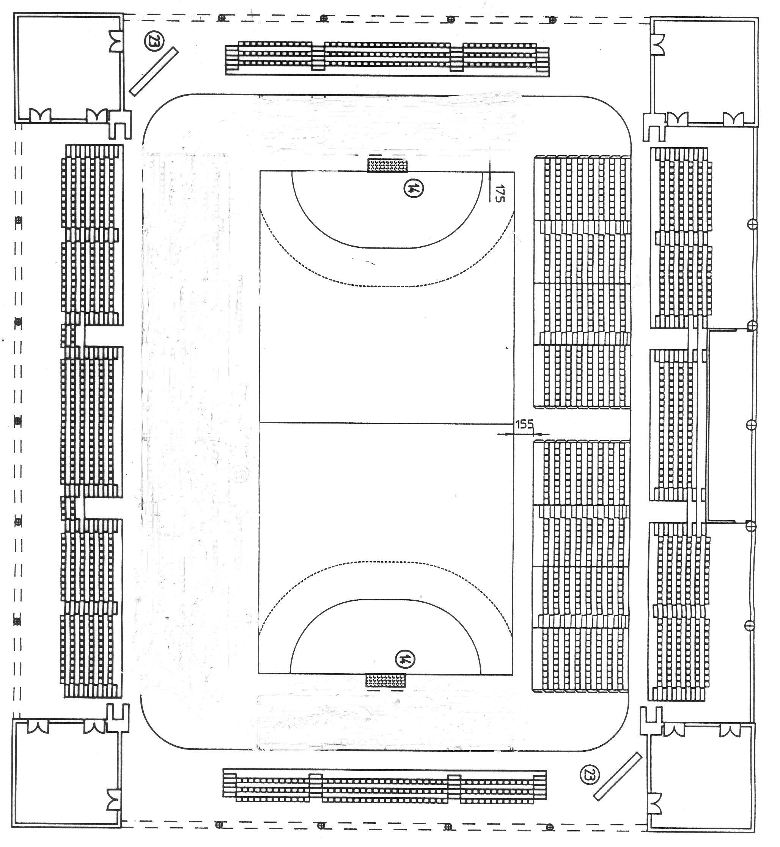

1000: U-12

1230: U-16

1000: U-10

1230: U-14

1400: U-18

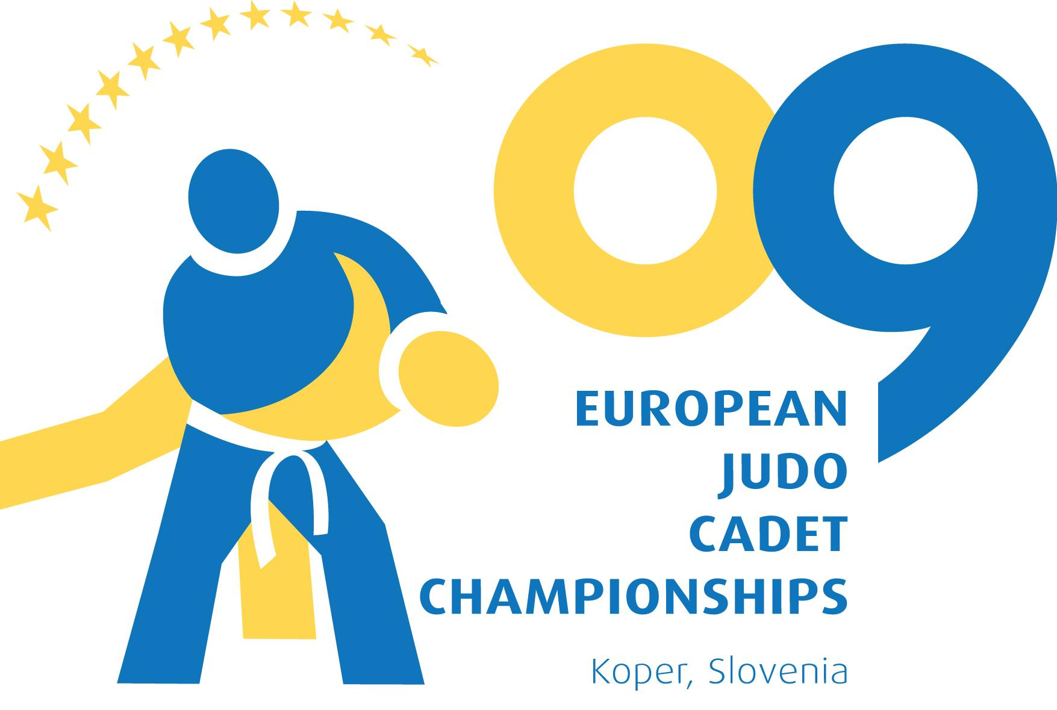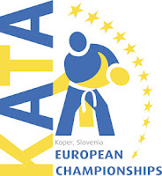*CLUB TEHNICAL ORGANIZER EC KADETS 2009 AND ORGANIZER EC KATA 2012*

***ACCOMMODATION FOR JUDO TOURNAMENT***

**1. Hotel Žusterna *** *We recommend you Hotel Žusterna, there are benefits included in favourable price ( only for our judo tournament):*** Price (bed with breakfast and dinner): 36 EURO/ per person/per day in double room and 51,50 EURO/ per person/per day in single room + 1,50 EURO chech-in free + Tourist tax: 1,27 (or 0,51 for young 7-18 year old) EURO/per person/per day.

The usage of  indoor pool included in price (heated pool with seawater and water slides)

Contact: 00386 5 6100 302, Martin Benčič: martin.bencic@terme-catez.si

<http://www.terme-catez.si/slovenska-obala/aquapark-zusterna/>

**2. Hotel Vodišek \*\*\***

Price (breakfast included):

40 EURO/per person/ per day

60 EURO/for 2 persons/ per day

75 EURO/for 3 persons/ per day

88 EURO/for 4 or 5 persons/ per day

Contact: tel.: 00386 5 6392468; [info@hotel-vodisek.com](mailto:info@hotel-vodisek.com); <http://www.hotel-vodisek.com/>

**3. Hostel Museum Koper**

16 EURO/ per person/ per day

4 EURO per breakfast

Contact: 00386 41 504466; [hostel.museum@gmail.com](mailto:hostel.museum@gmail.com); <http://www.hostel-museum.com/>;

**4. Hostel Histria Koper**

Price (only bed): 16 EURO/per person;

Price (bed and breakfast): 18 EURO/per person;

Contact: tel.: +386 (0)70 13 35 52; [histria.koper@youth-hostel.si](mailto:histria.koper@youth-hostel.si);

; <http://www.youth-hostel.si/hostels.asp?id=72#page=1>;

**5. Hostel IZOLA**

Price (bed and breakfast): 15 EURO/per person/ per day;

Contact: Vladka & Drago: tel.: 00386 40 208 010; [hostelizola@gmail.com](mailto:hostelizola@gmail.com); [www.hostelizola.com](http://www.hostelizola.com)

**6. Hostel Alieti Izola**

Price (bed and breakfast): 18 EURO/per person

Contact: tel.: 00386 51 670 680; [info@hostel-alieti.si](mailto:info@hostel-alieti.si); <http://www.hostel-alieti.si/>;

***PRECEEDING ENTRY FORM -* deadline Wednesday 12th October 2016**

CLUB (S.A.): ………………………….……….; nation: …………………………

|  |  |  |  |  |  |  |
| --- | --- | --- | --- | --- | --- | --- |
| **N°** | **Name and surname** | **Date of birth** | **Sex**  **(M o F)** | **Competition category** | **Weight category**  (only for U-14, 16 and 18) | **Weight**  **U-10** |
| 1 |  |  |  |  |  |  |
| 2 |  |  |  |  |  |  |
| 3 |  |  |  |  |  |  |
| 4 |  |  |  |  |  |  |
| 5 |  |  |  |  |  |  |
| 6 |  |  |  |  |  |  |
| 7 |  |  |  |  |  |  |
| 8 |  |  |  |  |  |  |
| 9 |  |  |  |  |  |  |
| 10 |  |  |  |  |  |  |
| 11 |  |  |  |  |  |  |
| 12 |  |  |  |  |  |  |
| 13 |  |  |  |  |  |  |
| 14 |  |  |  |  |  |  |
| 15 |  |  |  |  |  |  |
| 16 |  |  |  |  |  |  |
| 17 |  |  |  |  |  |  |
| 18 |  |  |  |  |  |  |
| 19 |  |  |  |  |  |  |
| 20 |  |  |  |  |  |  |
| 21 |  |  |  |  |  |  |
| 22 |  |  |  |  |  |  |

***Please send the preceding entry to:***

E- mail: [iztok.babič@siol.net](mailto:iztok.babič@siol.net);